Project Design Phase Problem – Solution Fit Template

Date | 01 November 2025
Team ID | 69c0be5ec71a9ebd6a51912e
Project Name | Streamlining Ticket Assignment for Efficient Support Operations
Maximum Marks

Problem – Solution Fit Template:
The Problem-Solution Fit simply means that you have found a problem with your internal customer (the ABC Corporation support department) and that the automated routing system you have built for it actually solves that customer’s problem.
In this project, the Problem is that support tickets are manually triaged, leading to delays, incorrect assignments, and wasted agent time. The Solution is the ServiceNow flow that automatically assigns tickets to the correct team based on the selected "Issue" type. The "Fit" is confirmed when this solution measurably reduces delays and manual effort.
It helps the project team, ServiceNow administrators, and support managers identify these behavioral patterns (e.g., agents wasting time re-assigning) and recognize what (automated routing) would work and why.
marketers and corporate innovators identify behavioral patterns and recognize what would work and why

Purpose:
- Solve complex problems in a way that fits the state of your customers.
- Succeed faster and increase your solution adoption by tapping into existing mediums and channels of behavior.
- Sharpen your communication and marketing strategy with the right triggers and messaging.
- Increase touch-points with your company by finding the right problem-behavior fit and building trust by solving frequent annoyances, or urgent or costly problems.
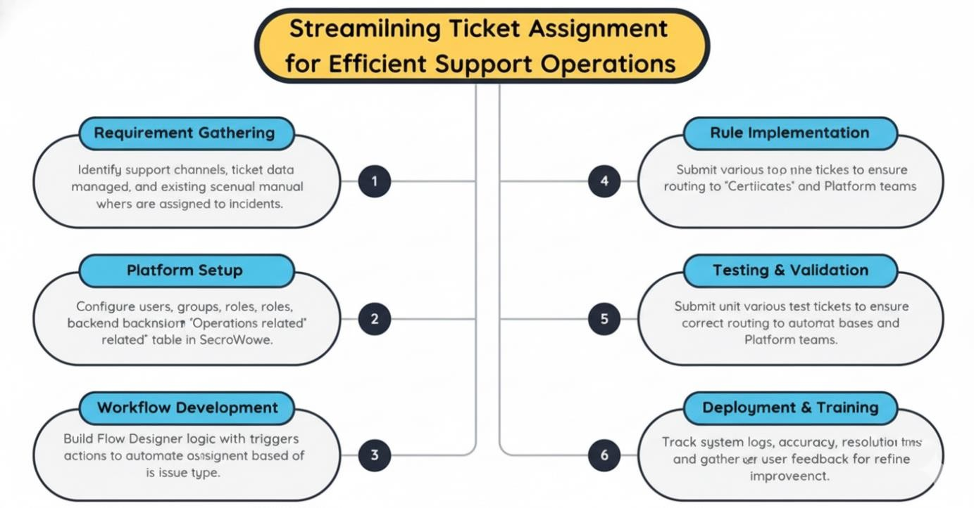
- Understand the existing situation in order to improve it for your target group.

The project "Streamlining Ticket Assignment for Efficient Support Operations" addresses a crucial gap in support operations and manual ticket triage. By ensuring that every incoming support ticket is automatically and accurately routed to the correct team based on its type, we significantly improve operational efficiency, issue resolution times, and customer satisfaction. This solution not only safeguards issue-resolution workflows from delays but also supports better resource optimization and SLA performance. With the successful implementation of automated routing rules using Flow Designer in platforms like ServiceNow, this project sets a foundation for building smarter and more responsive support systems in enterprise environments.

